

Phoenix Tongaat Verulam


GRADE 10


INFORMATION TECHNOLOGY P2
FINAL EXAMINATION - 2010

MARKS: 150 TIME: 2½ hours
EXAMINER: P. Moodley/ D. Chellan MODERATOR: M. Reddy

This question paper consists of 8 pages

SECTION A

Question 1
Choose the best answer (a – d) for every question and write down only the question number and the correct letter e.g. 1.3 c

1.1. Which one of the following terms does not logically belong with the others?
A. Keyboard B. Search Engine
C. Monitor D. Memory

1.2. Which one of the following is not a typical function of an operating system?
A. Virus detection B. Memory management
C. Resource allocation D. Control of peripheral devices

1.3 Which one of the following is NOT a component of the CPU?
A Control Unit B Arithmetic Logic Unit
C Registers D The control bus

1.4. The key on a keyboard most commonly associated with help functions is…
A. SysRq B. HELP
C. TAB D. F1

1.5 | Which one of the following is a typical example of a WAN?  A. Users connected via a Bluetooth connection  B. A network in a school  C. Any network linked with fiber optic cable  D. A country-wide network of a bank
1.6 | Which one of the following e-mail options allows you to send a copy of the message so that the recipient’s name is not visible to other recipients of the message?  A. Cc  B. To  C. Bcc  D. Forward

1.7 Which one of the following is an example of both an input and an output device?
A. Touch pad
B. Keyboard
C. Scanner
D. Touch screen

1.8. Which one of the following correctly arranges the typical capacity of the storage devices in descending order (from largest to smallest)?
A. Hard drive, CD, DVD, flash disk
B. DVD, hard drive, flash disk, stiffy disk
C. CD, hard drive, DVD, flash disk
D. Hard drive, DVD, CD, stiffy disk

1.9. Which one of the following statements concerning memory and storage is false?
A. Memory needs constant power if it is to retain its contents.
B. Because RAM is electronic, it is much faster than storage which is mechanical.
C. You need much more RAM than storage on a PC.
D. Data is stored optically or magnetically on storage devices.

1.10. Memory that keeps its information even if the power is switched off.
A. RAM B. EDO RAM
C. ROM D. DDR 300 SDRAM
[10]
QUESTION 2

Match Column A with Column B. Write down only the letter from column B that corresponds with the description/phrase in column A.
Column A | Column B
2.1 The electronic equivalent of ‘junk mail’ sent out in bulk without the recipients requesting it. | A | ADSL
2.2 A hardware component manufactured by companies such as Intel, AMD and Motorola. | B | Spam
2.3 The speed of a computer processor is measured in | C | CPU
2.4 A port commonly used to connect hardware ranging from printers to flash disks. | D | USB
2.5 In a database , this field uniquely identifies a  Record. | E | dpi
2.6 Is a non-impact printer. | F | Freeware
2.7 A unit of measurement of resolution associated with both monitors and printers. | G | VOiP
2.8 A technology that allows voice conversations to take place via a network such as the Internet. | H | Laptop
2.9 Software that is copyrighted but costs  nothing. | I | GHz
2.10 This type of computer is more expensive to repair and almost impossible to upgrade. | J | Laser Printer
 | K | Primary key
[10]
Section B: Hardware and System Software

Read the following scenario and then answer the questions that follow.

Scenario:

You are employed in the IT division of a company called Easy Office Application. This is a small business establishment that is steadily growing.

In addition to you there is a small group of contractors that are assigned the larger projects such as software development that are assigned the larger projects that are taken on by the company.

Question 3: Computer Architecture and Hardware[25]

PC Zone has been given the contract of supplying computers to the company and offered the management a choice of two computer packages presented below. The management require your assistance in deciding which of the packages to choose.

Computer A Computer B

Intel Pentium 4 2.8 GHz AMD 3.02 GHz
180 GB HDD 80 GB HDD
512 MB RAM 1 GB RAM
21” SVGA colour monitor 17” SVGA colour monitor
DVD/CD-writer combo drive CD writer
MS Windows XP Home MS-Office 2007
Optical mouse HP laser printer
MS-Office 2003 Infra-red mouse
Free Zeon ink-jet printer 56 K fax modem
Ergonomically designed QWERTY keyboard Bluetooth keyboard
Free digital camera Free 512 MB flash disk

3.1 | The management is concerned that computer B has a poor quality monitor.  In terms of the monitor explain to the management what 21” and 17” represent and how is it measured? |  | (2)
3.2 | Name the Operating Software installed in Computer A. |  | (1)
3.3 | Which computer has more RAM?  What is the advantage of having more RAM? |  | (2)
3.4 | The management heard about the term ROM and wants to know what it is. Explain to the management what ROM is by explaining the difference between RAM and ROM. |  | (2)
3.5 | What function does the MODEM serve in Computer B? |  | (1)
3.6 | The management is not happy with the inkjet printer supplied with Computer A. They preferred a laser printer. Clearly explain the difference between an inkjet and a laser printer. |  | (2)
3.7 | Briefly explain why the optical mouse is better than the track ball mouse. |  | (2)
3.8 | Computer A comes with an ergonomically designed keyboard.  Explain to the management:  3.8.1 What “ergonomics” is?  3.8.2 What does this ergonomically designed keyboard have that an ordinary keyboard does not have?  3.8.3 What does QWERTY mean. |  | (2)  (2)  (1)
3.9 | Computer A comes with a Intel Pentium 4 2.8 GHz.  3.9.1 Which company manufactures the Pentium  3.9.2 Explain to the management what Pentium and AMD refer to in a computer and what the difference between the two is. |  | (1)  (2)
3.10 | Would the management be able to watch DVD’s in Computer B?  Explain why or why not. |  | (2)
3.11 | The management is happy about the free digital camera that comes with Computer A. They say that it would be useful to take out pictures during matches and post them on the Internet.  List three advantages of a digital camera over a conventional camera? |  | (3)
 |  |  | [25]

Question 4: Operating System and System Software [26]

You need to explain certain software concepts to the company, so that they can buy the software that they need for their business.

4.1 Software is divided into two categories, i.e. application software and system software.
State the difference between both. (2)

4.2 Under which type of software does an OS fall? (1)

4.3 From the advertisement for Computer A, provide an example of:
4.3.1 System software (1)
4.3.2 Application software (1)
4.4 What are the THREE main functions of any OS? (6)

4.5 The advert offers the software package Microsoft Windows XP Home for Computer A.
Would it be legal to install this program on more than one computer at the business if
the program was legally purchased and licensed? Briefly motivate your answer by discussing the following licensing agreements.
4.5.1 Single – user
4.5.2 Multi - user (5)

4.6 List 2 examples of utility software. (2)

4.7 Expand the following software acronyms:

4.7.1 GUI (1)

4.7.2 GPS (1)

  - Jane, an employee at Easy Office Application is having problems with the hardware on her
computer. I asked her whether she has loaded the driver for the device.
She looked confused and worried.
4.8.1 Explain to Jane, what a driver is. (2)

4.9 State the difference between plug & play and hot swappable. (4)

[26]

Question 5: Data Communication and Networks [19]

Easy Office Application proposes to communicate by means of the post (snail mail) and telephone, but there are many alternative ways of communicating in today’s world.

5.1 Discuss any TWO electronic modes of communication, except for email, and how
they can be used in this business. (4)

5.2 Describe the four different sections in Easy office Application’s e-mail address. (4)
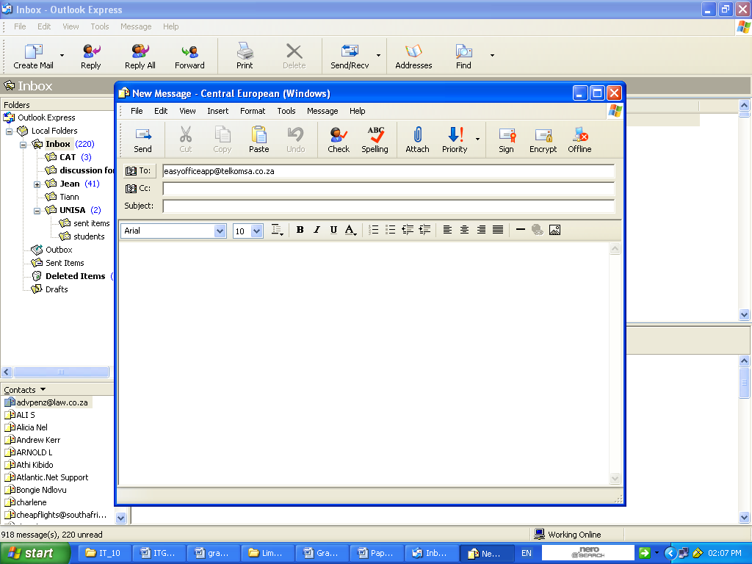

5.3 Mr Noah (The CEO) is worried that he might get a virus if he opens the attachment.

5.3.1. Is it possible to get a virus from the attachment? (1)
5.3.2. What is a computer virus? (2)
5.3.3. Name TWO safety measures that can be taken to prevent your system from
getting infected with viruses when opening e-mails. (2)
5.3.4 Name THREE symptoms of a virus infected computer. (3)

5.4 List 3 rules of netiquette that one must observe when communicating via email. (3)

[19]

SECTION C: Applications and Implications

Question 6: e-Communication and Social and Ethical Issues [17]

Easy Office Application wishes to make use of their Internet site in terms of promoting their business. They currently use Telkom as their ISP .

6.1 List two benefits of e-commerce to the business. (2)
6.2 What requirements( components) must be satisfied in order for your client to
connect to the internet? (4)
6.3 Expand the following software acronyms:
6.3.1 ISP (1)
6.3.2 WWW (1)
6.3.4 RSI (1)

6.4. Name one social networking site and list TWO dangers of this site. (3)

6.5 Mr Noah is anxious about the employees spending prolonged periods of time in front
of the computers as he has heard that computers can have an adverse effect on their health.

6.5.1 List THREE ways in which computers can possibly contribute to ill health. (3)
6.5.2 List TWO common-sense, practical precautions that you could take to prevent (2)
your health being adversely affected by prolonged use of a computer
[17]
SECTION D
Question 7: Programming and Software Development [20]

7. In developing programs, it is important to determine what data needs to be input and the type of the data.
7.1. What is meant by the term data type and what is the significance of it in terms of the program? (2)

7.2 There are two types of loops used in virtually all programming languages, namely
unconditional loops and the conditional loops.

7.2.1 Explain the difference between an unconditional- loop and a conditional loop
by referring to a suitable example or set of circumstances when you would use
each one. (4)

7.3 Easy Office Application is rapidly expanding. Mr Noah employs 2 more people.
Their income for the week is determined by multiplying hours worked by an hourly rate.

A tax of 12% is deducted if the gross weekly wage is R 1000 or more and 8% if it is less than a R 1000. Each employee’s wage is calculated by subtracting the deductions from
the income.

7.3.1 List TWO variables (give suitable names) that are required in order to calculate
the salary of a single employee. Provide the data type for each variable. (4)
7.3.2 Write an algorithm to determine and output the weekly wage of a single employee. (6)

7.4 Differentiate between logical errors and syntax errors. (2)
7.5 List 2 debugging techniques that can be used. (2)
SECTION E: INTEGRATED SCENARIO

Question 8: [23]
Because of the rapid growth of the business, I suggested to the management that it would be wise to network the computers between the various offices in the building. This is a new and scary concept to them.
Answer the following questions that they ask.

8.1 What is a network? (2)
8.2 Provide two reasons why it is advisable to set up a network in the business. (2)
8.3 Explain to the management what is a LAN . (2)

8.4 Mr Noah wants to know how he can search for information on the Internet. I recommend
that a uses a reliable search engine.

8.4.1 Briefly explain what a search engine is and how it works. (2)

8.4.2 List the name of any ONE commonly used search engine. (1)

8.4.3 Suggest TWO ways in which Mr Noah can narrow his search down so that
he can achieve more meaningful results. (2)

8.5 Mr Noah wants to know what are the advantages of internet banking. List 2 advantages of internet banking for him. (2)

8.6 One of the downsides of being connected to the Internet and using e-mail identity theft and phishing . Explain what is:
8.6.1 Identity theft (2)
8.6.2 Phishing (2)
8.7 Easy Office Application is concerned about the large amounts of paper usage and environment impact caused by increased computer usage .
8.7.1 Discuss TWO ways of saving paper. (2)
8.7.2 State how green computing can help contribute to the environment (2)

8.8 Explain what is digital divide (2) [23]

TOTAL: 150/5*6 = 180

